STEM Education: Strategies for Success FIG
Fall 2018- Meeting 1
September 26, 2018

Concept Inventories

Physics: Force Concept Inventory https://www.physport.org/assessments/assessment.cfm?A=FCI

Hestenes, D, Wells, M, and Gregg Swackhamer, G. 1992. Force Concept Inventory The Physics Teacher, Vol. 30, March, 141-158.

Calculus concept inventory: https://www.physport.org/assessments/assessment.cfm?I=57&A=CCI

Chemical Concepts Inventory: https://www.chemedx.org/JCEDLib/QBank/collection/CQandChP/CQs/ConceptsInventory/CCIIntro.html
Chemistry: Pavelich, M, Jenkins, B., Birk, J, Bauer, R, Krause, S. 2004 Development of a chemistry concept inventory for use in chemistry, materials and other engineering ASEE Annual Conference Proceedings pp. 3445-3452

Genetics: Smith, Wood, and Knight The Genetics Concept Assessment: A New Concept Inventory for Gauging Student Understanding of Genetics. CBE Life Sciences Education Vol 7 No. 4

General Microbiology: Citation: Paustian T, Briggs A, Brennan R, Boury N, Buchner J, Harris S, Horak R, Hughes L, Katz-Amburn D, Massimelli M, McDonald A, Primm T, Smith A, Stevens A, Yung S. 2017. Development, validation, and application of the microbiology concept inventory † . J. Microbiol. Biol. Educ. 18(3): doi:10.1128/jmbe.v18i3.1320

Allied Health Microbiology Citation: Seitz H, Horak R, Howard M, Kluckhohn Jones L, Muth T, Parker C, Rediske A, Whitehurst M. Development and validation of the microbiology for health sciences concept inventory † . J. Microbiol. Biol. Educ. 18(3): doi:10.1128/jmbe.v18i3.132

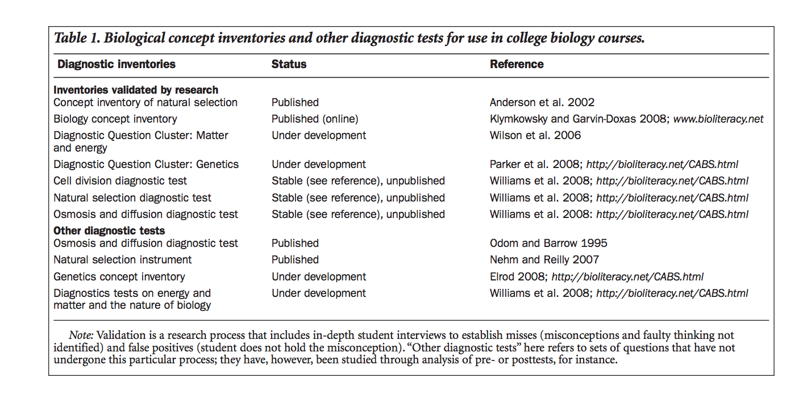

Creation
- True false questions
- Students answer and were asked to explain their reasoning
- Misconceptions were identified
- Multiple choice questions were generated using the misconceptions as distractors.

