Summary of STEM FIG Discussion
March 25-26, 2019

Topic: Racial achievement and motivation gaps related to faculty mindset

Article: “STEM faculty who believe ability is fixed have larger racial achievement gaps and inspire less student motivation in their classes,” E.A. Canning, et al., Science Advances 2019.
http://advances.sciencemag.org/content/5/2/eaau4734

Summary:

In this recent study, 150 STEM faculty across 13 departments at a large public university were surveyed (using a validated tool) to identify their beliefs regarding the fixedness of academic or intellectual ability. Course grades for 15,000 students who took courses with these instructors over seven terms were analyzed using a regression model to determine the presence and size of any effect of instructor mindset on student achievement. Students were separated into two categories, white/Asian and URM (underrepresented minorities including black, Hispanic, and native American). Faculty mindset predicted student achievement more than any other faculty characteristic (faculty race, age, experience, gender, tenure status), and was more pronounced for URM than for white/Asian students. The two figures below (copied from the article) summarize these results, as well as the results of student evaluations for each course.

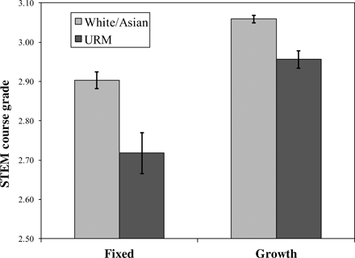

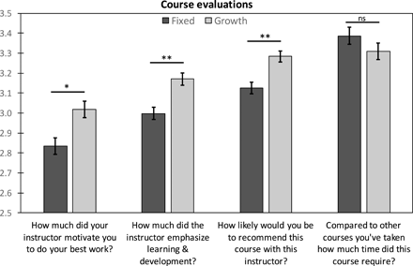

Discussion questions:

- How can mindset be determined? What questions were asked in the faculty survey? (see full article or a few examples) How could I identify such beliefs in myself? (often they are unrecognized)
- What can be done to mitigate the effect of such beliefs? How can these beliefs be changed?
- What pedagogical practices communicate a growth mindset to students, as opposed to a fixed mindset? (a few suggestions are given in the full article)

